

**COMPUTER VISION USING OPENCV**

**23SDAD10E**

**LAB WORKBOOK**

**Course Coordinator :** **Dr. Sandeep Reddy Chitreddy**

**STUDENT ID: 2310080078 ACADEMIC YEAR: 2025-26**

**STUDENT NAME: EELAPANTI MYTHRI**

**SEM/YEAR: 3RD year Odd sem**

**DEPARTMENT: AI & DS**

**Table of Contents**

|  |  |  |  |
| --- | --- | --- | --- |
| **S. No.** | **List of Experiments** | **Session** | **Page No.** |
| 1 | Experiment 1: Reading Images |  |  |
| 2 | Experiment 2 : Placing Logo on Image |  |  |
| 3 | Experiment 3 : Reading video from Webcam |  |  |
| 4 | Experiment 4 : Placing Logo on Webcam |  |  |
| 5 | Experiment 5 : Running mp4 video through OpenCV |  |  |
| 6 | Experiment 6 : Resizing using OpenCV |  |  |
| 7 | Experiment 7 : Live Video Capture using IP Webcam |  |  |
| 8 | Experiment 8 : Image Rotation |  |  |
| 9 | Experiment 9 : Image Transformations and Flipping |  |  |
| 10 | Experiment 10 : Image Gray scaling |  |  |
| 11 | Experiment 11 : Increase Brightness without using OpenCV |  |  |
| 12 | Experiment 12 : Changing Contrast of an Image |  |  |
| 13 | Experiment 13 : Binary Representation |  |  |
| 14 | Experiment 14 : BGR to HSV |  |  |
| 15 | Experiment 15 : Tracking using Color in HSV Domain |  |  |
| 16 | Experiment 16 : Convolution using filter2D : Negative values allowed |  |  |
| 17 | Experiment 17 : Fourier Transform |  |  |
| 18 | Experiment 18 : DFT of two sinusoids |  |  |
| 19 | Experiment 19 : 2d DFT of two dimensional sinusoids |  |  |
| 20 | Experiment 20 : Verifying Convolution in time domain is multiplication in frequency domain |  |  |
| 21 | Experiment 21 : Low Pass Filtering of 1D Signals |  |  |
| 22 | Experiment 22 : Record sound in python |  |  |
| 23 | Experiment 23 : Low pass and High pass filtering of real audio file |  |  |
| 24 | Experiment 24 : Morphological Operations |  |  |

|  |  |  |  |  |  |  |  |  |  |  |
| --- | --- | --- | --- | --- | --- | --- | --- | --- | --- | --- |
| **S. No** | **Date** | **Experiment Name** | **Pre-**  **Lab**  **(10M)** | **In-Lab (25M)** | | | **Post-**  **Lab**  **(10M)** | **Viva**  **Voce**  **(5M)** | **Total**  **(50M)** | **Faculty**  **Signature** |
| **Program/**  **Procedure**  **(5M)** | **Data and**  **Results**  **(10M)** | **Analysis &**  **Inference**  **(10M)** |
| **1.** |  | Experiment 1 : Reading Images |  |  |  |  |  |  |  |  |
| **2.** |  | Experiment 2 : Placing Logo on Image |  |  |  |  |  |  |  |  |
| **3.** |  | Experiment 3 : Reading video from Webcam |  |  |  |  |  |  |  |  |
| **4.** |  | Experiment 4 : Placing Logo on Webcam |  |  |  |  |  |  |  |  |
| **5.** |  | Experiment 5 : Running mp4 video through OpenCV |  |  |  |  |  |  |  |  |
| **6.** |  | Experiment 6 : Resizing using OpenCV |  |  |  |  |  |  |  |  |

|  |  |  |  |  |  |  |  |  |  |  |
| --- | --- | --- | --- | --- | --- | --- | --- | --- | --- | --- |
| **S. No** | **Date** | **Experiment Name** | **Pre-**  **Lab**  **(10M)** | **In-Lab (25M)** | | | **Post-**  **Lab**  **(10M)** | **Viva**  **Voce**  **(5M)** | **Total**  **(50M)** | **Faculty**  **Signature** |
| **Program/**  **Procedure**  **(5M)** | **Data and**  **Results**  **(10M)** | **Analysis &**  **Inference**  **(10M)** |
| **7.** |  | Experiment 7 : Live Video Capture using IP Webcam |  |  |  |  |  |  |  |  |
| **8.** |  | Experiment 8 : Image Rotation |  |  |  |  |  |  |  |  |
| **9.** |  | Experiment 9 : Image Transformations and Flipping |  |  |  |  |  |  |  |  |
| **10.** |  | Experiment 10 : Image Gray scaling |  |  |  |  |  |  |  |  |
| **11.** |  | Experiment 11 : Increase Brightness without using OpenCV |  |  |  |  |  |  |  |  |
| **12.** |  | Experiment 12 : Changing Contrast of an Image |  |  |  |  |  |  |  |  |
| **`13.** |  | Experiment 13 : Binary Representation |  |  |  |  |  |  |  |  |
| **14.** |  | Experiment 14 : BGR to HSV |  |  |  |  |  |  |  |  |
| **15.** |  | Experiment 15 : Tracking using Color in HSV Domain |  |  |  |  |  |  |  |  |
| **16.** |  | Experiment 16 : Convolution using filter2D : Negative values allowed |  |  |  |  |  |  |  |  |
| **17.** |  | Experiment 17 : Fourier Transform |  |  |  |  |  |  |  |  |
| **18.** |  | Experiment 18 : DFT of two sinusoids |  |  |  |  |  |  |  |  |
| **19.** |  | Experiment 19 : 2d DFT of two dimensional sinusoids |  |  |  |  |  |  |  |  |
| **20.** |  | Experiment 20 : Verifying Convolution in time domain is multiplication in frequency domain |  |  |  |  |  |  |  |  |
| **21.** |  | Experiment 21 : Low Pass Filtering of 1D Signals |  |  |  |  |  |  |  |  |
| **22.** |  | Experiment 22 : Record sound in python |  |  |  |  |  |  |  |  |
| **23.** |  | Experiment 23: Low pass and High pass filtering of real audio file |  |  |  |  |  |  |  |  |
| **24.** |  | Experiment 24: Morphological Operations |  |  |  |  |  |  |  |  |

Experiment 1: Reading Images

Method 1 to read images:

import matplotlib.pyplot as plt

import matplotlib.image as img

image=img.imread('Cat.jpg')

plt.imshow(image[:,:,:])

plt.show()

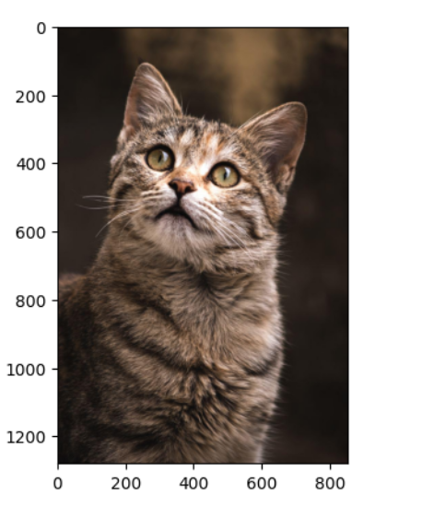

3D

import numpy as np

img = np.array([[[1],[2]],[[3],[4]]]) #3-D

print(img.shape)

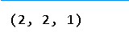

4D

import numpy as np

a = np.array([[[[2,3]],[[4,5]]],[[[4,5]],[[7,8]]]]) # 4-D

print(a.shape)

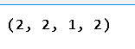

To read image from terminal using Pillow Library, first create a virtual environment named mycvenv using below command:

python3 -m venv mycvenv

Activate virtual environment using one of below commands:

For Mac: source myenv/bin/activate

For Windows: .\myenv\Scripts\activate

Install Pillow library using below code:

pip3 install Pillow

Now place the below code in a python file and run it using python3 from terminal

from PIL import Image

img=Image.open('Cat.jpg')

img.show()

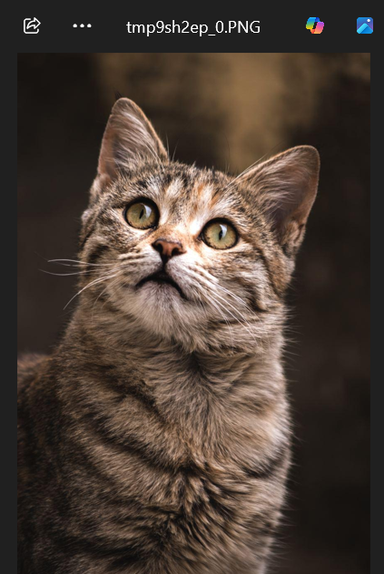

Install Opencv using below command

pip install opencv-python

import cv2

image1=cv2.imread('Cat.jpg')

type(image1)

cv2.imshow("Image",image1)

cv2.waitKey(0)

cv2.destroyAllWindows()

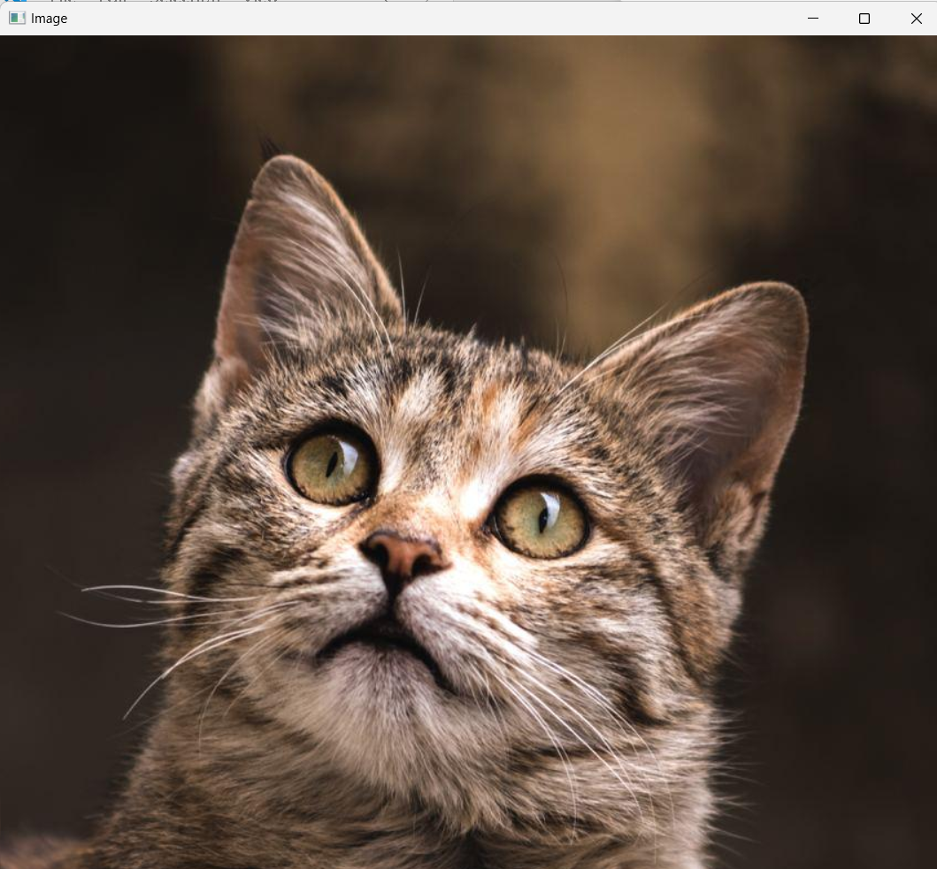

Experiment 2: Placing Logo on Image

Home Assignment 1: Place KLH logo on the Cat image to the top right corner

import cv2

# Read the main image and logo

image = cv2.imread('Cat.jpg')

logo = cv2.imread('klh.jpg')

# Resize logo if needed (optional, here resized to 200x100)

logo = cv2.resize(logo, (200, 100))

# Get dimensions

image_height, image_width = image.shape[:2]

logo_height, logo_width = logo.shape[:2]

# Define the position for the top-right corner

top_left_y = 0

top_left_x = image_width - logo_width

# Place the logo on the image

image[top_left_y:top_left_y + logo_height, top_left_x:top_left_x + logo_width] = logo

# Show the result

cv2.imshow("Image with Logo", image)

cv2.waitKey(0)

cv2.destroyAllWindows()

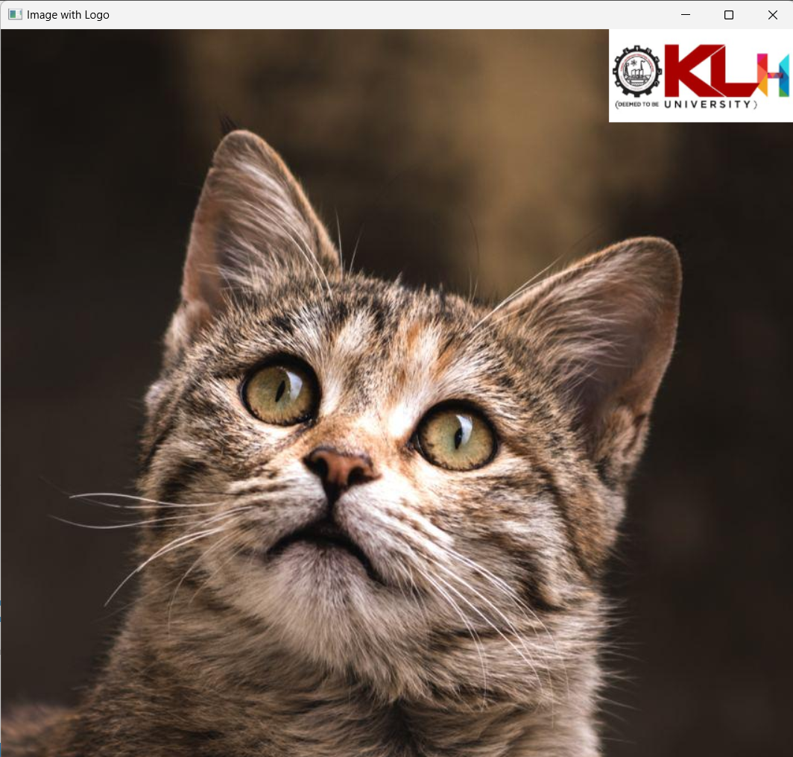

Experiment 3: Reading video from Webcam

#Reading video from Webcam:

import cv2

cap= cv2.VideoCapture('Earth.mp4')

if (cap.isOpened() == False):

    print("Error opening video file")

while (cap.isOpened()):

    ret, frame = cap.read()

    if ret == True:

        cv2.imshow('Frame', frame)

        if cv2.waitKey(25) & 0xFF == ord('q'):

            break

    else:

        break

cap.release()

cv2.destroyAllWindows()

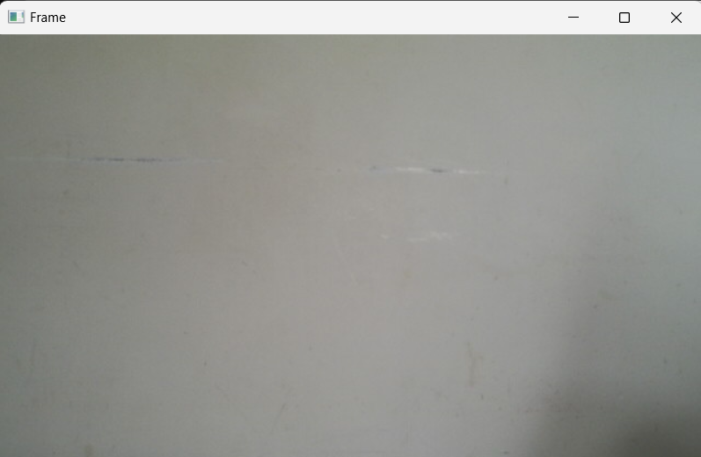

Experiment 4: Placing Logo on Webcam

Home Assignment 2: Place KLH logo on the video recorded using Webcam

import cv2

# Open webcam

video = cv2.VideoCapture(0)

# Read logo image

logo = cv2.imread('klh.jpg')

logo = cv2.resize(logo, (200, 100))  # Resize if needed

if not video.isOpened():

    print("Error reading video stream")

    exit()

# Get video frame dimensions

frame_width = int(video.get(cv2.CAP_PROP_FRAME_WIDTH))

frame_height = int(video.get(cv2.CAP_PROP_FRAME_HEIGHT))

# Resize logo to fit frame better, optional

logo_height, logo_width = logo.shape[:2]

# Top-right corner placement

top_left_y = 0

top_left_x = frame_width - logo_width

# Video writer setup

size = (frame_width, frame_height)

result = cv2.VideoWriter('filename.avi', cv2.VideoWriter_fourcc(*'MJPG'), 10, size)

while True:

    ret, frame = video.read()

    if ret:

        # Overlay the logo on the frame

        frame[top_left_y:top_left_y + logo_height, top_left_x:top_left_x + logo_width] = logo

        # Write and show the frame

        result.write(frame)

        cv2.imshow('Frame with Logo', frame)

        # Exit on 's' key

        if cv2.waitKey(1) & 0xFF == ord('s'):

            break

    else:

        break

# Release everything

video.release()

result.release()

cv2.destroyAllWindows()

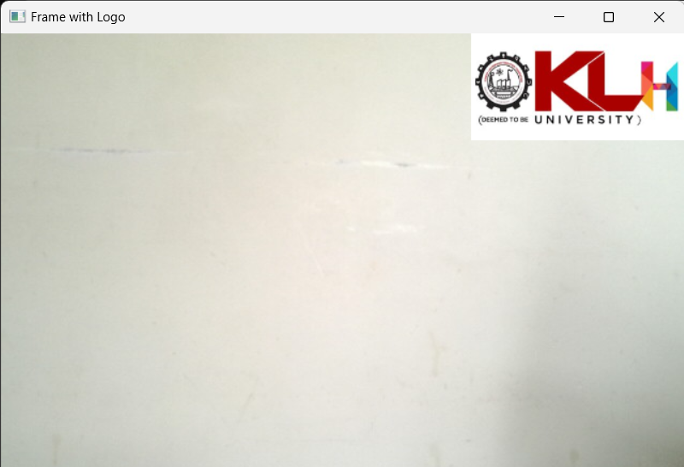

Experiment 5: Running mp4 video through OpenCV

import cv2

cap= cv2.VideoCapture('Earth.mp4')

if (cap.isOpened() == False):

    print("Error opening video file")

while (cap.isOpened()):

    ret, frame = cap.read()

    if ret == True:

        cv2.imshow('Frame', frame)

        if cv2.waitKey(25) & 0xFF == ord('q'):

            break

    else:

        break

cap.release()

cv2.destroyAllWindows()

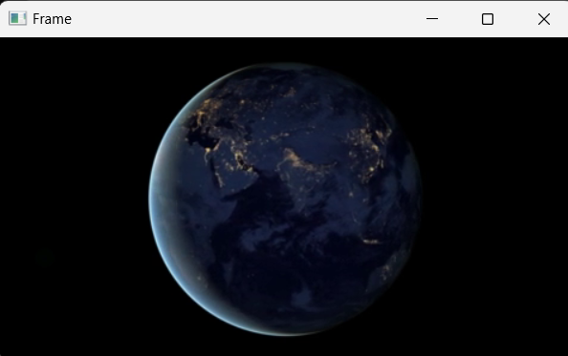

Experiment 6: Resizing using OpenCV

import cv2

img = cv2.imread('messi5.jpg')

half = cv2.resize(img, (0, 0), fx = 0.4, fy = 0.4)

bigger = cv2.resize(img, (1024, 1024))

print(img.shape)

print(half.shape)

print(bigger.shape)

cv2.imshow("Image1",img)

cv2.waitKey(0)

cv2.destroyAllWindows()

cv2.imshow("Image2",half)

cv2.waitKey(0)

cv2.destroyAllWindows()

cv2.imshow("Image3",bigger)

cv2.waitKey(0)

cv2.destroyAllWindows()

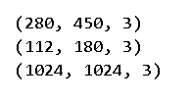

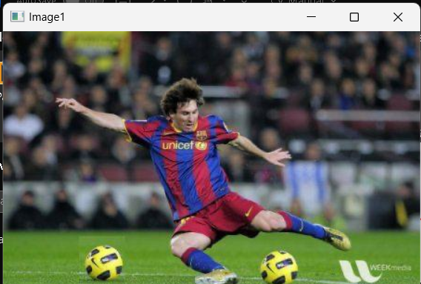

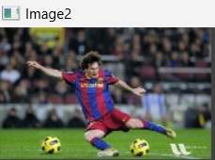

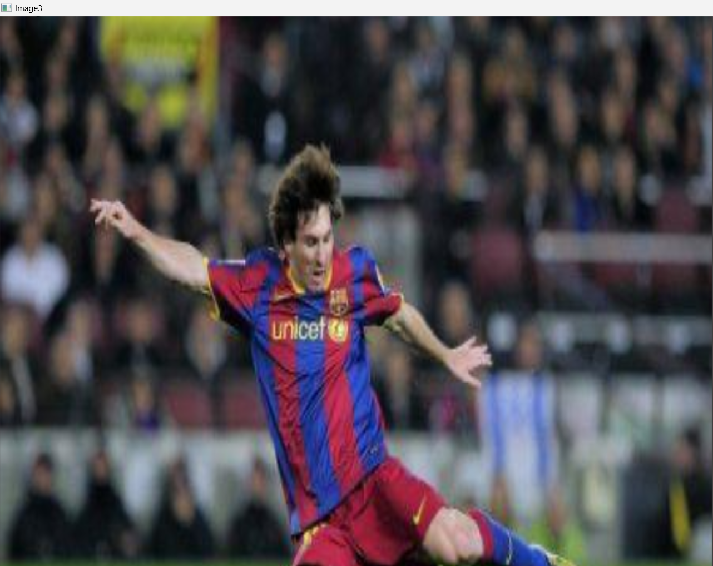

Experiment 7: Live Video Capture using IP Webcam

import cv2

import numpy as np

url = "http://192.168.0.101:8080/video"

cp = cv2.VideoCapture(url)

while(True):

    camera, frame = cp.read()

    if frame is not None:

        cv2.imshow("Frame", frame)

    q = cv2.waitKey(1)

    if q==ord("q"):

        break

cv2.destroyAllWindows()

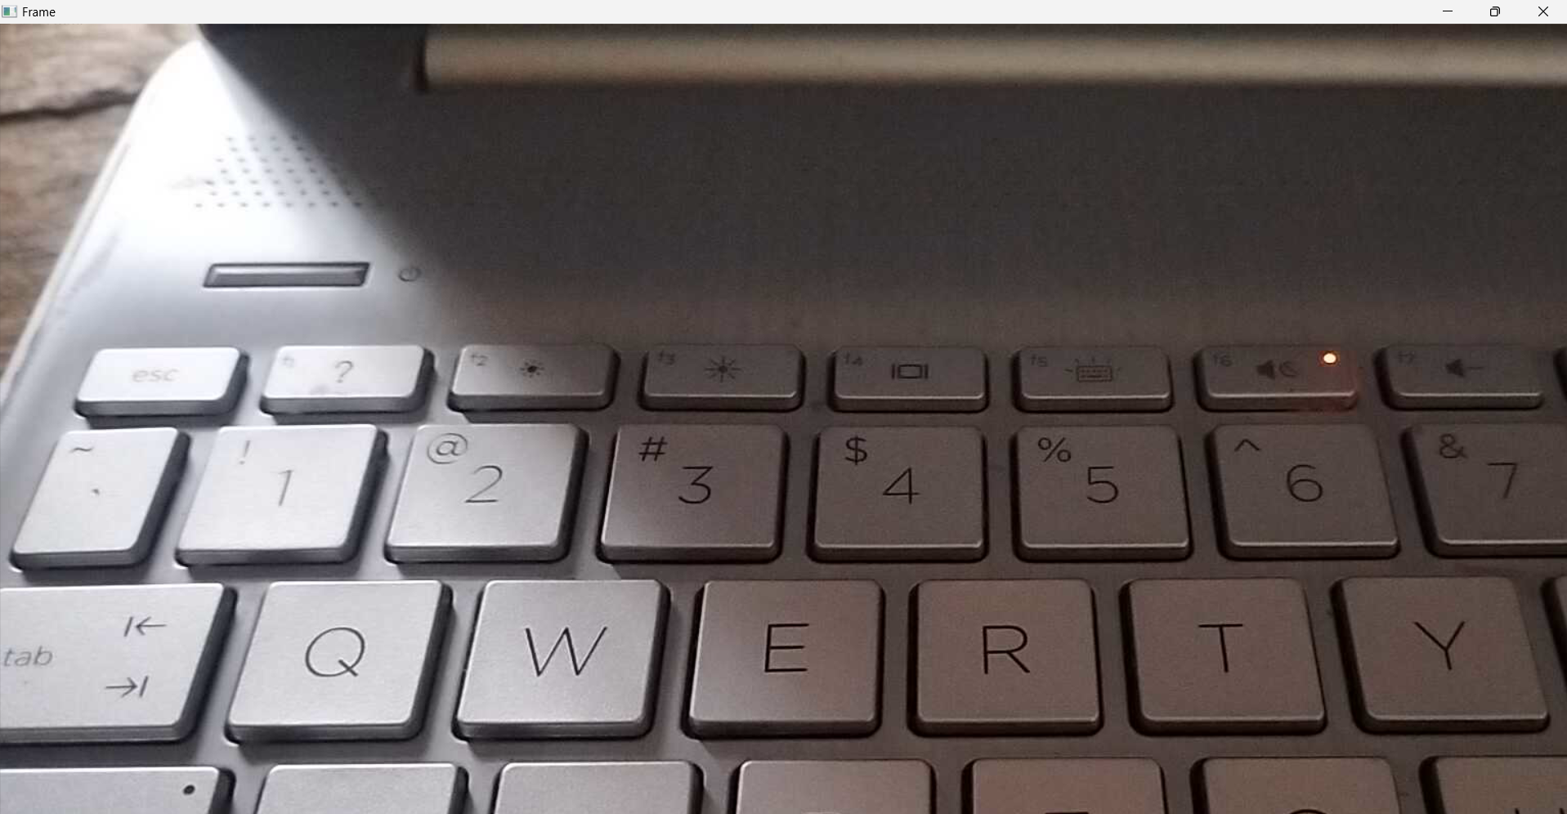

Experiment 8: Image Rotation

import cv2

img = cv2.imread('messi5.jpg')

# dividing height and width by 2 to get the center of the image

height, width = img.shape[:2]

# get the center coordinates of the image to create the 2D rotation matrix

center = (width / 2, height / 2)

# using cv2.getRotationMatrix2D() to get the rotation matrix

rotate_matrix = cv2.getRotationMatrix2D(center=center, angle=80, scale=0.5) #####change angle 45,80....

print(rotate_matrix)

# rotate the image using cv2.warpAffine

rotated_image = cv2.warpAffine(src=img, M=rotate_matrix, dsize=(width, height))

cv2.imshow("Image",img)

print("Image Rotation")

cv2.imshow("RImage",rotated_image)

cv2.waitKey(0)

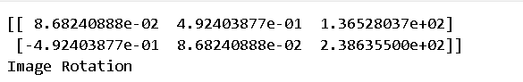

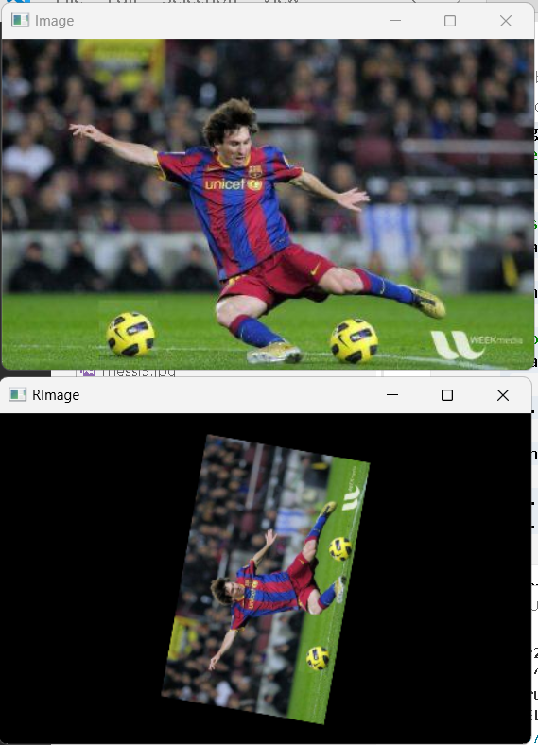

Experiment 9: Image Transformations and Flipping

import cv2

import numpy as np

image = cv2.imread('Cat.jpg')

rows, cols = image.shape[:2]

# Shear matrix (x-shear)

shear_matrix = np.float32([[1, 0.5, 0],

                           [0,   1, 0]])

# Apply affine transform

sheared_image = cv2.warpAffine(image, shear_matrix, (int(cols * 1.5), rows))

h_flip = cv2.flip(image, 1)

v_flip = cv2.flip(image, 0)

both_flip = cv2.flip(image, -1)

cv2.imshow("Original", image)

cv2.waitKey(0)

cv2.imshow("Sheared (Skewed)", sheared_image)

cv2.waitKey(0)

cv2.imshow("HFlip", h_flip)

cv2.waitKey(0)

cv2.imshow("VFlip", v_flip)

cv2.waitKey(0)

cv2.imshow("HVFlip", both_flip)

cv2.waitKey(0)

cv2.destroyAllWindows()

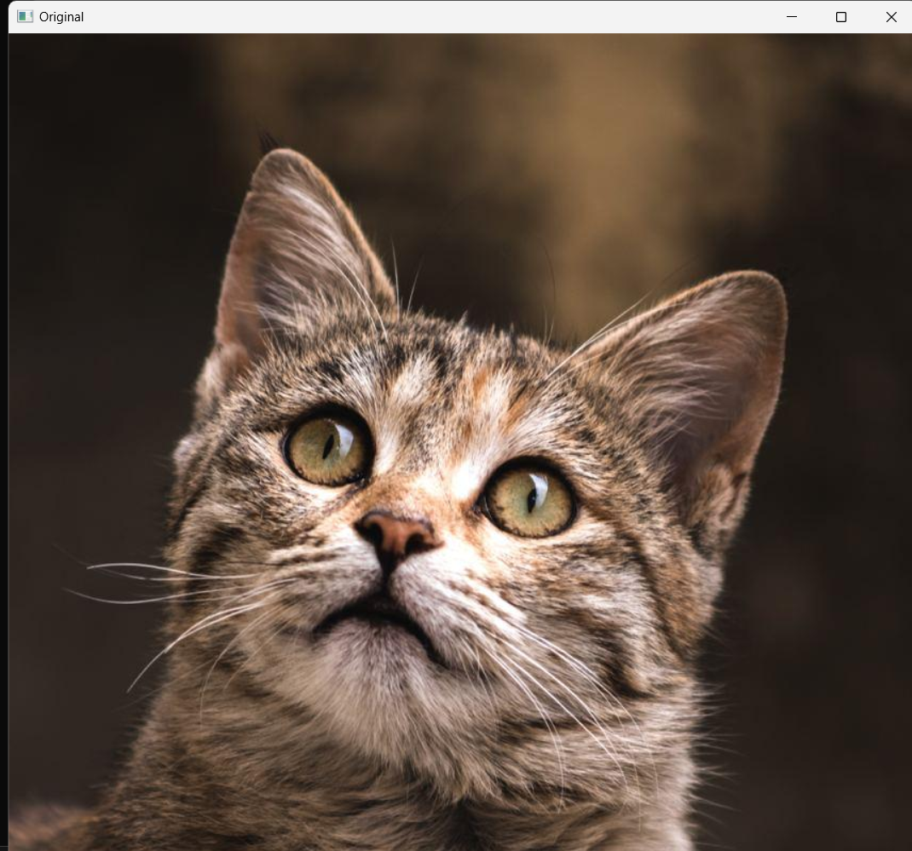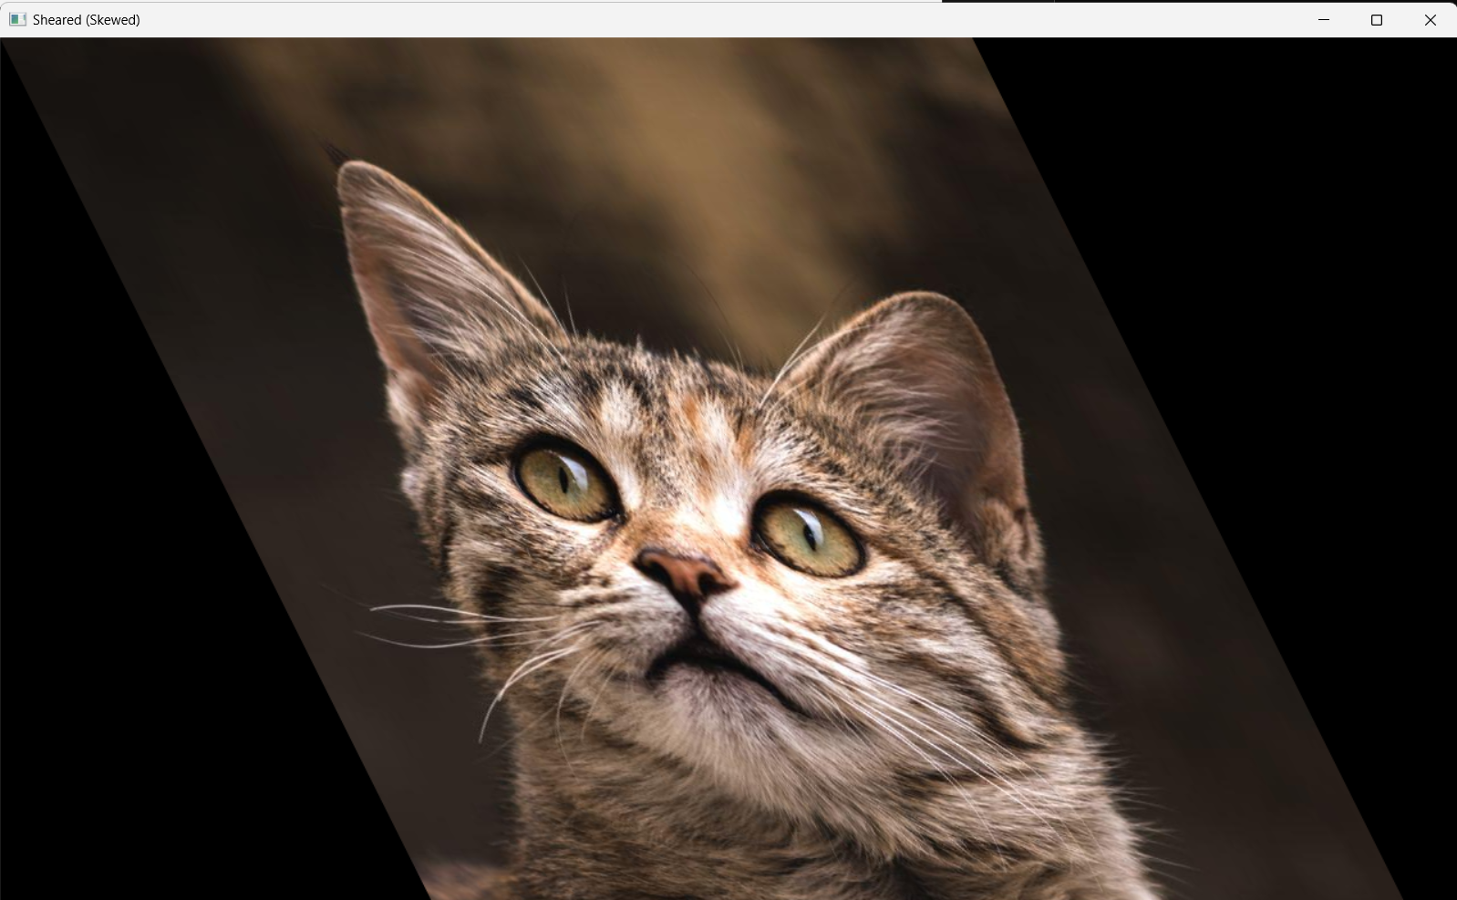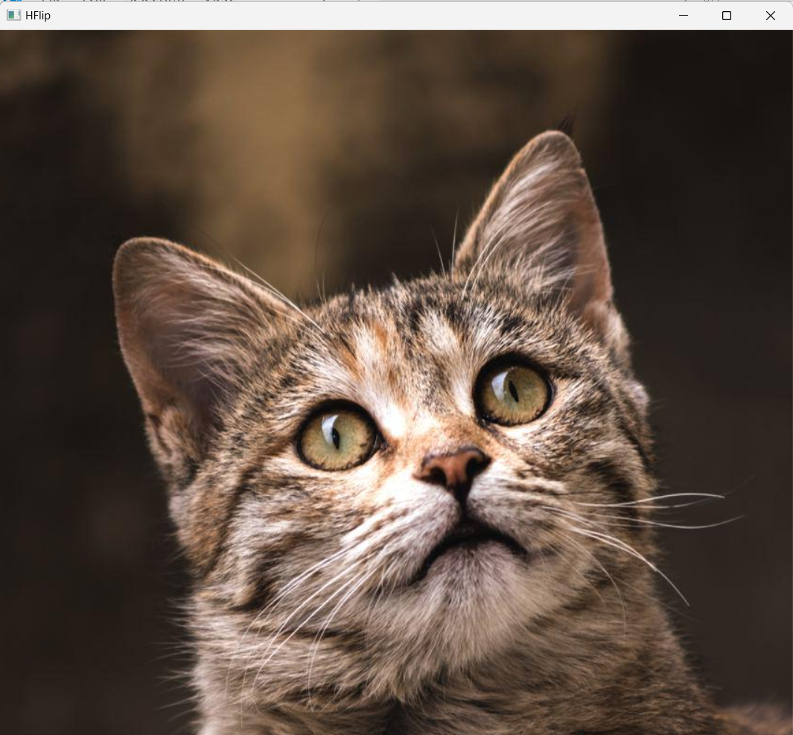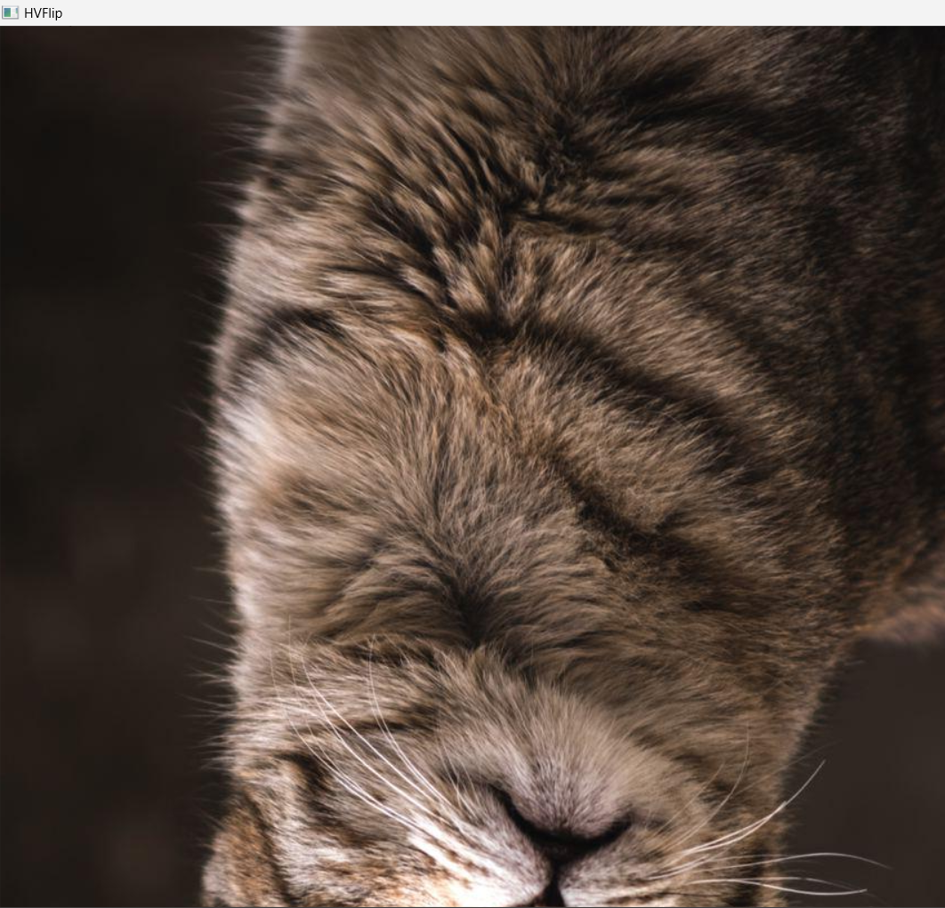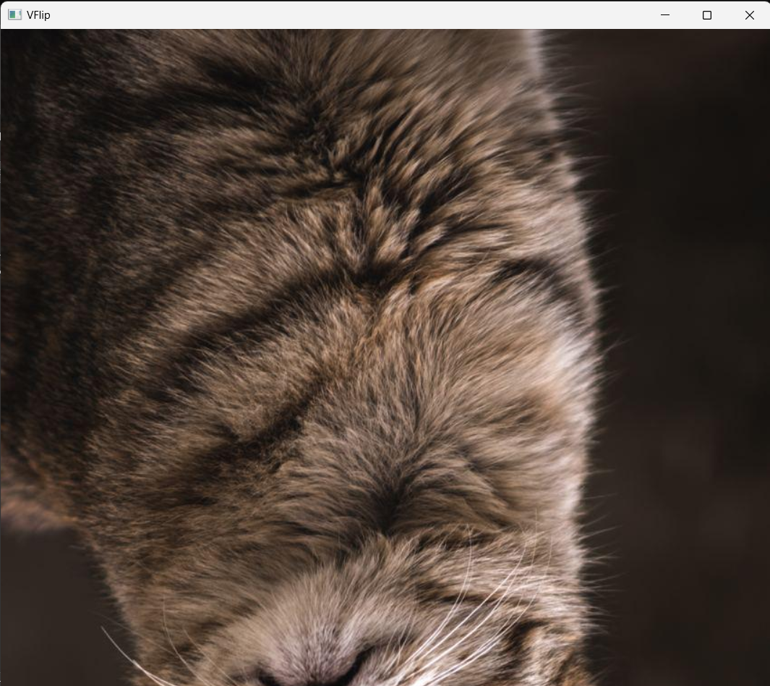

Experiment 10: Image Gray scaling

import cv2

img = cv2.imread('Cat.jpg', 0)  # Load in grayscale

cv2.imshow('Grayscale Cat', img)  # Window title and image

cv2.waitKey(0)  # Wait for a key press

cv2.destroyAllWindows()  # Close all OpenCV windows

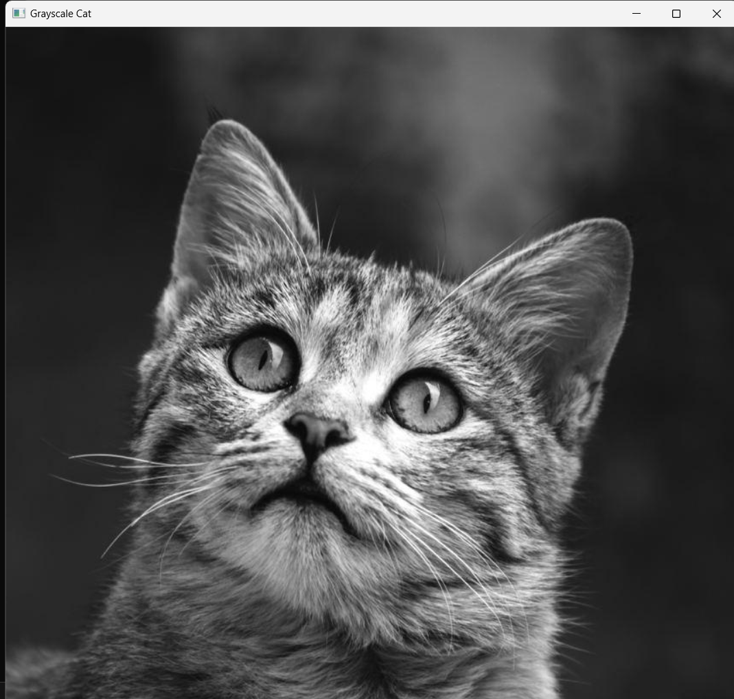

Experiment 11: Increase Brightness without using OpenCV

import cv2

import numpy as np

# Read grayscale image

img = cv2.imread('Cat.jpg', 0)

# Add 20 to each pixel but cap at 255

img1 = np.clip(img + 20, 0, 255).astype(np.uint8)

# Show original and modified images

cv2.imshow("Original", img)

cv2.imshow("Increased Brightness", img1)

cv2.waitKey(0)

cv2.destroyAllWindows()

(or)

import cv2

import numpy as np

# Load grayscale image

img = cv2.imread('Cat.jpg', 0)

# Create a new image to store the result

bright_img = np.zeros(img.shape, dtype=np.uint8)

# Get image dimensions

rows, cols = img.shape

# Increase brightness by 20 using 2 for loops

for i in range(rows):

    for j in range(cols):

        new_value = img[i, j] + 20

        if new_value > 255:

            new_value = 255

        bright_img[i, j] = new_value

# Show the result

cv2.imshow('Brightened Image', bright_img)

cv2.waitKey(0)

cv2.destroyAllWindows()

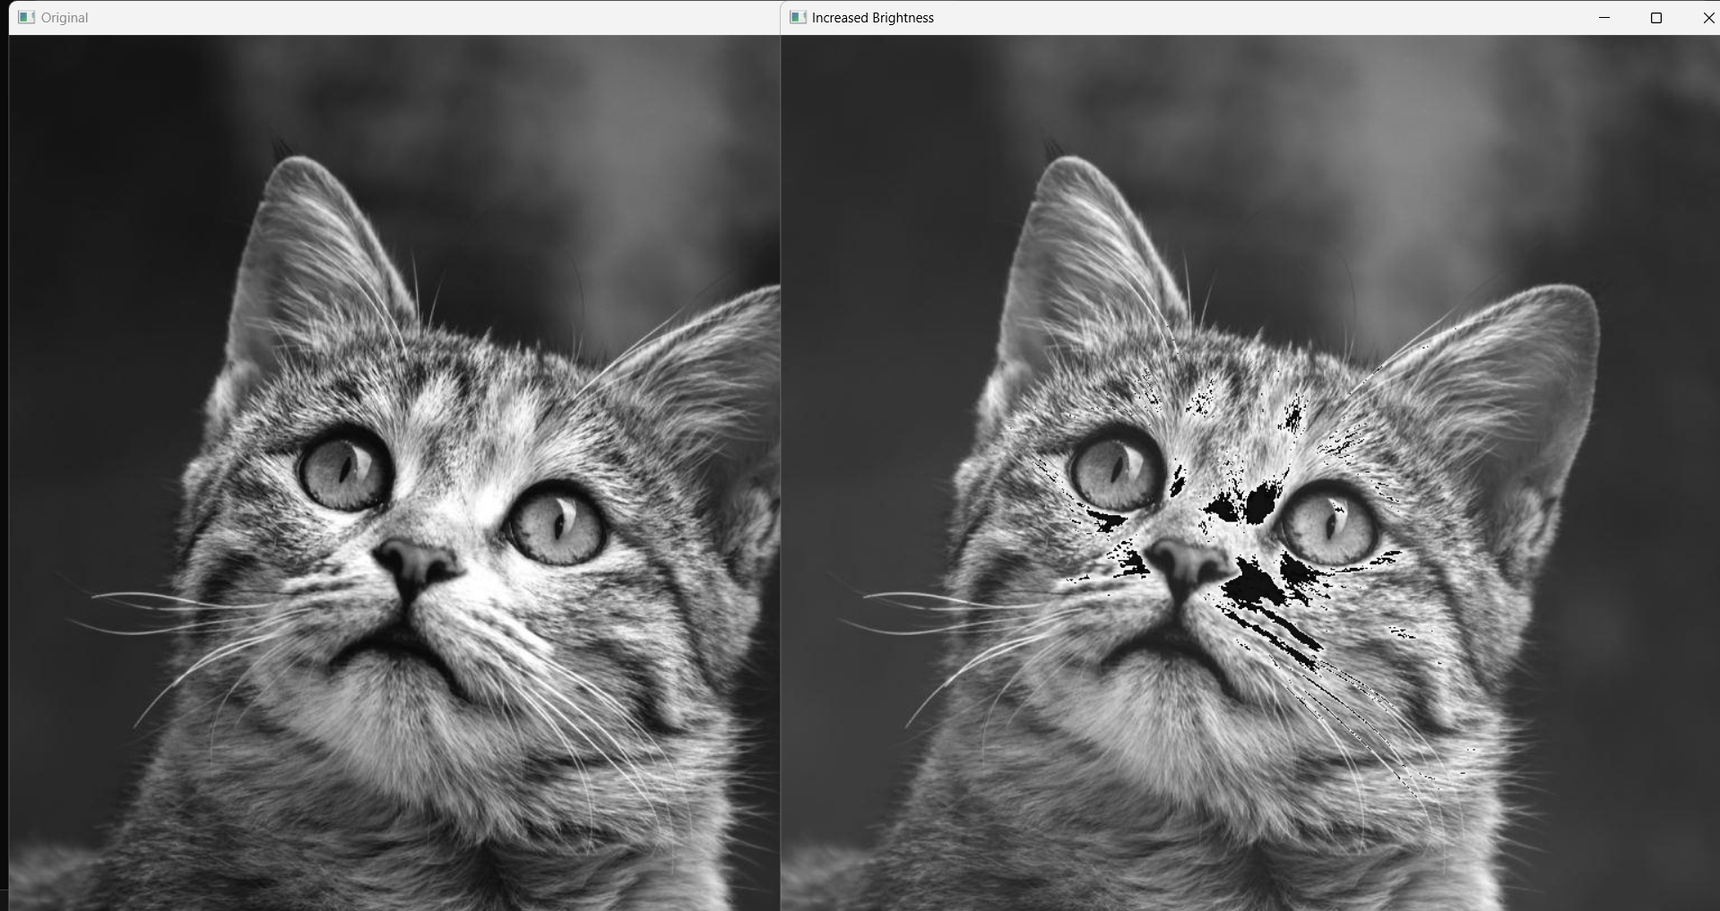

Experiment 12: Changing Contrast of an Image

import cv2

import numpy as np

def contrast_stretch(img):

    a, b = 20, 230  # new range

    rmin, rmax = np.min(img), np.max(img)

    stretched = (img - rmin) * ((b - a) / (rmax - rmin)) + a

    return np.uint8(stretched)

img = cv2.imread('Cat.jpg', 0)

cv2.imshow("Original", img)

cv2.waitKey(0)

stretched_img = contrast_stretch(img)

cv2.imshow("Contrast Stretched", stretched_img)

cv2.waitKey(0)

cv2.destroyAllWindows()

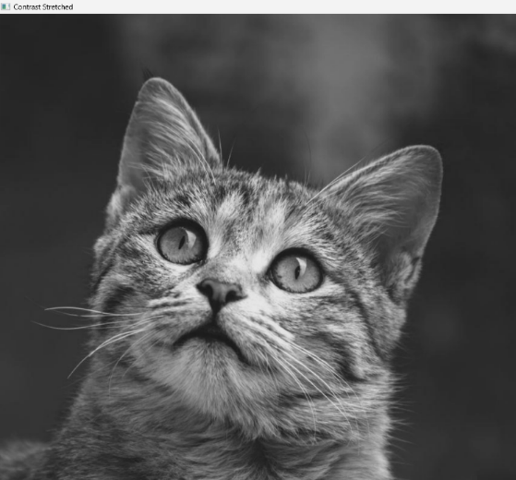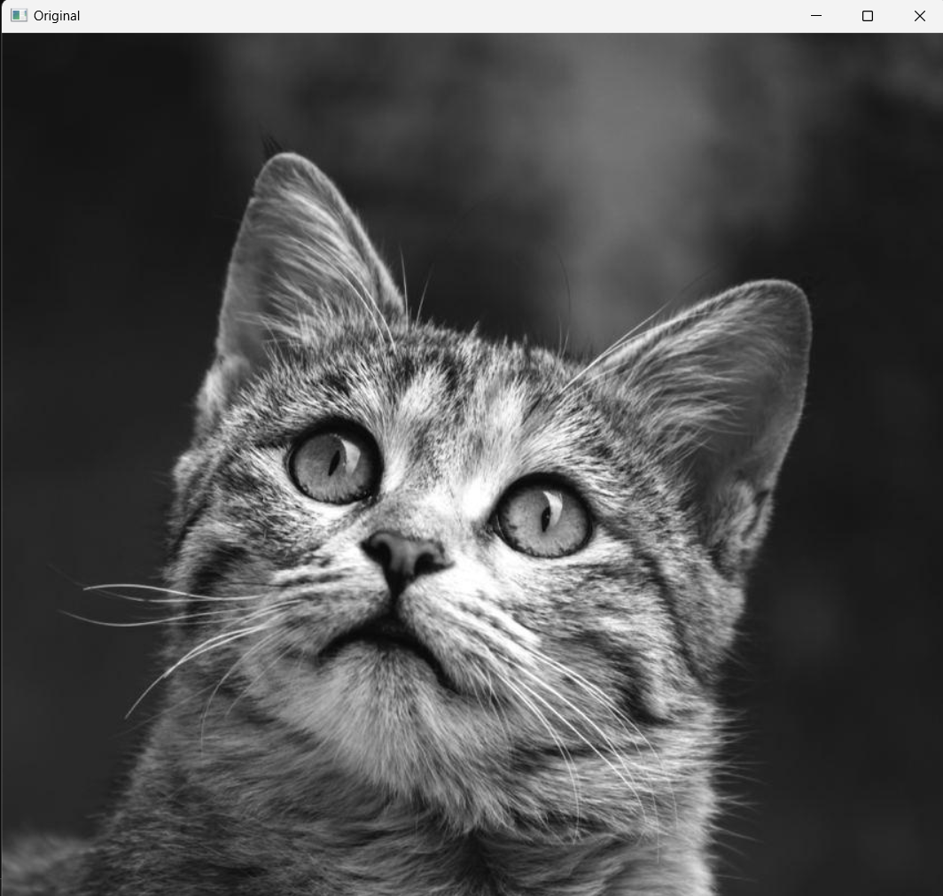

Experiment 13: Binary Representation

import cv2

img = cv2.imread('Cat.jpg', 0)

_, thresh = cv2.threshold(img, 127, 255, cv2.THRESH_BINARY)

cv2.imshow("Thresholded", thresh)

cv2.waitKey(0)

cv2.destroyAllWindows()

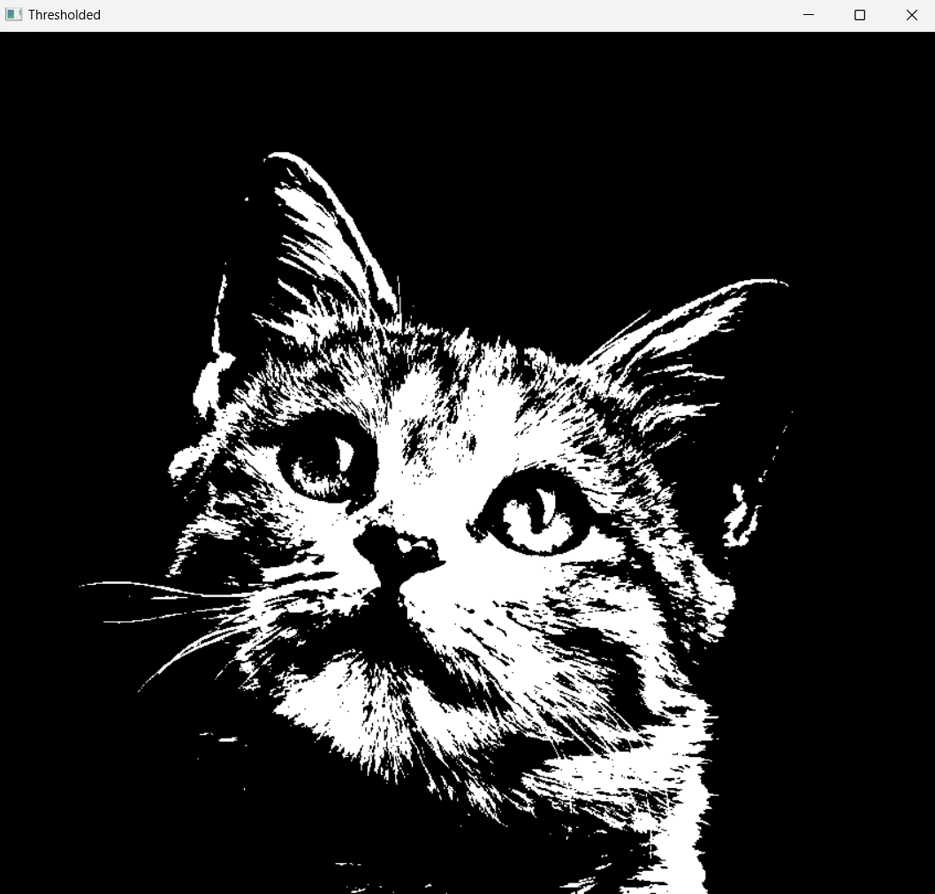

Experiment 14: BGR to HSV

import cv2

# Read the image from file

image = cv2.imread('Cat.jpg')

# Convert the image from BGR to HSV color space

hsv_img = cv2.cvtColor(image, cv2.COLOR_BGR2HSV)

hsv_img

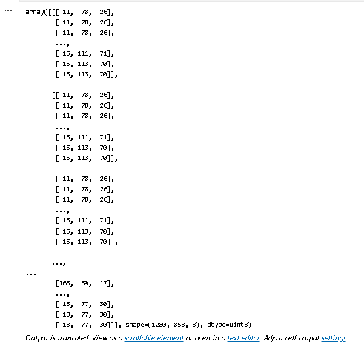

Experiment 15: Tracking using Color in HSV Domain

import cv2 as cv

import numpy as np

cap = cv.VideoCapture(0)

if not cap.isOpened():

    print("Cannot open camera")

    exit()

while True:

    ret, frame = cap.read()

    if not ret:

        print("Can't receive frame. Exiting ...")

        break

    hsv = cv.cvtColor(frame, cv.COLOR_BGR2HSV)

    lower_blue = np.array([110, 50, 50])

    upper_blue = np.array([130, 255, 255])

    mask = cv.inRange(hsv, lower_blue, upper_blue)

    res = cv.bitwise_and(frame, frame, mask=mask)

    cv.imshow('frame', frame)

    cv.imshow('mask', mask)

    cv.imshow('res', res)

    if cv.waitKey(1) & 0xFF == 27:  # ESC key

        break

cap.release()

cv.destroyAllWindows()

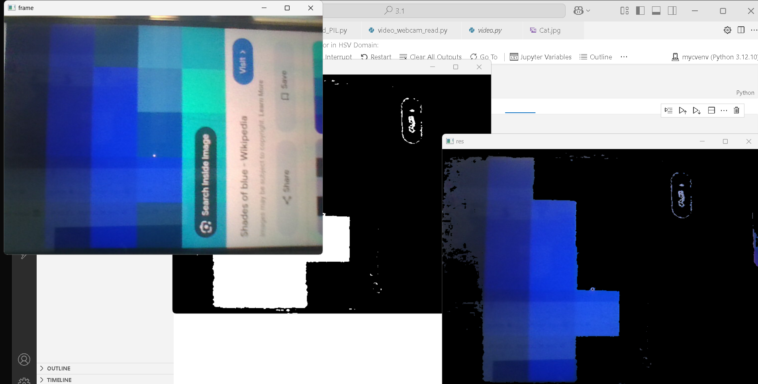

Experiment 16: Convolution using filter2D : Negative values allowed

import cv2

import numpy as np

a=np.array([[1,2,3],[4,5,6],[7,8,9]],dtype=np.uint8)

b=np.array([[-1,0,1],[-2,0,2],[-1,0,1]],dtype=np.float32)

print(a)

print(b)

b1=cv2.flip(b,-1)

c=cv2.filter2D(src=a,ddepth=cv2.CV_32F,kernel=b1,borderType=cv2.BORDER_CONSTANT)

print(c)

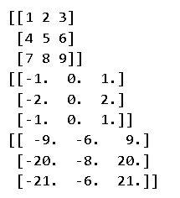

#Convolution

import cv2

import numpy as np

image=cv2.imread('taj.jpg')

gray = cv2.cvtColor(image, cv2.COLOR_BGR2GRAY)

k=np.array([[-1,0,1],[-2,0,2],[-1,0,1]])

# k=k/6

output=cv2.filter2D(src=gray,ddepth=-1,kernel=k)

cv2.imshow("Image",gray)

cv2.imshow("Output",output)

cv2.waitKey(0)

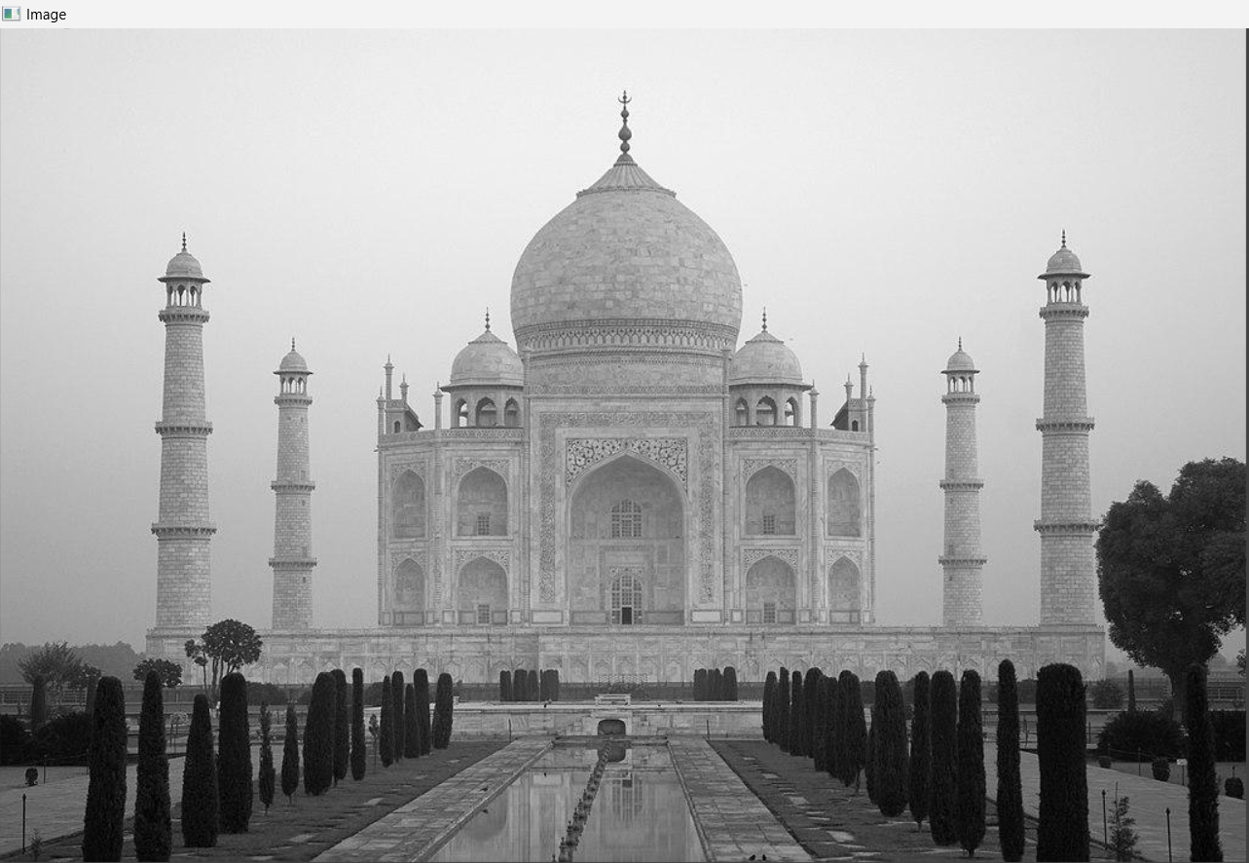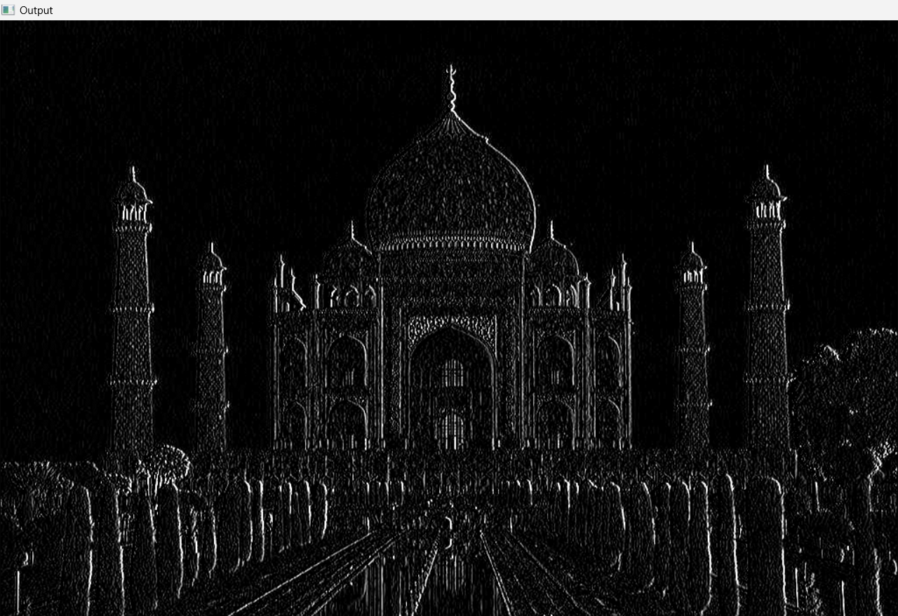

Experiment 17: Fourier Transform

# Fourier Transform

import numpy as np

x = [1, 4, 3, 2]  # input sequence

x = np.fft.fft(x)

print(x)

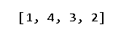

Experiment 18: DFT of two sinusoids

#DFT of two sinusoids:

import numpy as np

import matplotlib.pyplot as plt

# Parameters

Fs = 1000          # Sampling frequency in Hz

T = 1              # Duration in seconds

f = 49            # Frequency of sine wave in Hz

t = np.linspace(0, T, int(Fs*T), endpoint=False)  # Time vector

# Generate sine wave

x = np.sin(2 * np.pi * f * t)+np.sin(2 * np.pi * 25 * t)

# Compute DFT using FFT

X = np.fft.fft(x)

N = len(X)

frequencies = np.fft.fftfreq(N, 1/Fs)

# Plot time-domain signal

plt.figure(figsize=(12, 5))

plt.subplot(1, 2, 1)

plt.plot(t, x)

plt.title("Sine Wave in Time Domain")

plt.xlabel("Time [s]")

plt.ylabel("Amplitude")

# Plot magnitude spectrum (only positive frequencies)

plt.subplot(1, 2, 2)

plt.stem(frequencies[:N//2], np.abs(X[:N//2]) * 2 / N)

plt.title("Magnitude Spectrum (DFT)")

plt.xlabel("Frequency [Hz]")

plt.ylabel("Magnitude")

plt.tight_layout()

plt.grid(True)

plt.show()

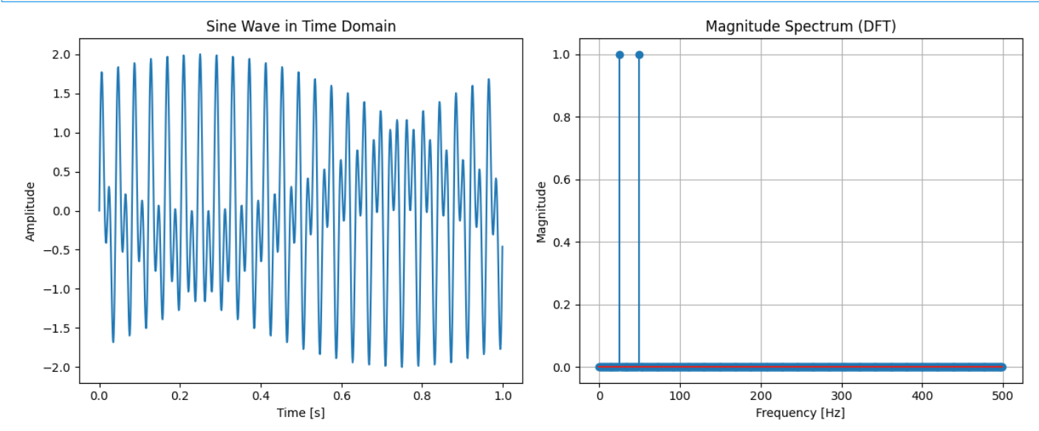

Experiment 19: 2d DFT of two dimensional sinusoids

# 2d DFT of two dimensional sinusoids:

import numpy as np

import matplotlib.pyplot as plt

# Create a 2D signal (e.g., 2D sinusoidal pattern or a small grayscale image)

N = 64

x = np.arange(N)

y = np.arange(N)

X, Y = np.meshgrid(x, y)

# Create 2D sine wave pattern

f1, f2 = 5, 10  # frequencies in x and y directions

image = np.sin(2 * np.pi * f1 * X / N) + np.sin(2 * np.pi * f2 * Y / N)

# Compute 2D DFT

dft2d = np.fft.fft2(image)

dft_shifted = np.fft.fftshift(dft2d)  # shift zero freq to center

magnitude_spectrum = np.abs(dft_shifted)

# Plot original 2D signal and its magnitude spectrum

plt.figure(figsize=(12, 5))

plt.subplot(1, 2, 1)

plt.imshow(image, cmap='gray')

plt.title("Original 2D Signal (Sine Pattern)")

plt.colorbar()

plt.subplot(1, 2, 2)

plt.imshow(np.log1p(magnitude_spectrum), cmap='gray')  # log scale for visibility

plt.title("2D DFT Magnitude Spectrum (log scale)")

plt.colorbar()

plt.tight_layout()

plt.show()

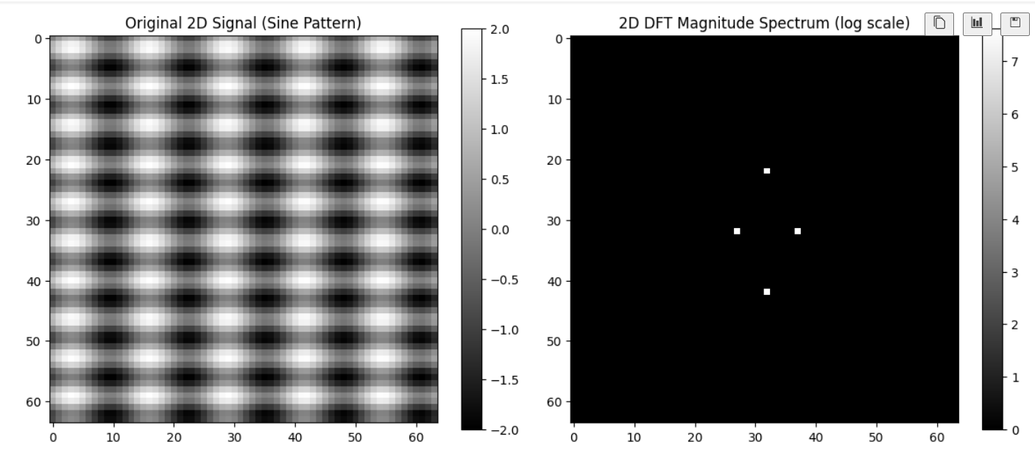

Experiment 20: Verifying Convolution in time domain is multiplication in frequency domain

# Verifying Convolution in time domain is multiplication in frequency domain:

import numpy as np

import matplotlib.pyplot as plt

# Define two signals

x = np.array([1, 2, 3, 4])

h = np.array([1, 1, 1])

# 1. Time-domain convolution

conv_time = np.convolve(x, h)

# 2. Frequency-domain multiplication

N = len(conv_time)  # length needed to avoid circular convolution

X = np.fft.fft(x, N)

H = np.fft.fft(h, N)

Y_freq = X * H

conv_freq = np.fft.ifft(Y_freq).real  # back to time domain

# Round small imaginary parts caused by numerical errors

conv_freq = np.round(conv_freq, decimals=5)

# Print results

print("Time domain convolution:     ", conv_time)

print("Freq domain (IFFT of mult):  ", conv_freq)

# Optional: plot to visualize

plt.figure(figsize=(10, 4))

plt.stem(range(len(conv_time)), conv_time, linefmt='b-', markerfmt='bo', basefmt=' ', label='Time-domain Convolution')

plt.stem(range(len(conv_freq)), conv_freq, linefmt='r--', markerfmt='ro', basefmt=' ', label='Freq-domain IFFT(X*H)')

plt.title("Convolution Theorem Demo")

plt.xlabel("n")

plt.ylabel("Amplitude")

plt.legend()

plt.grid(True)

plt.tight_layout()

plt.show()

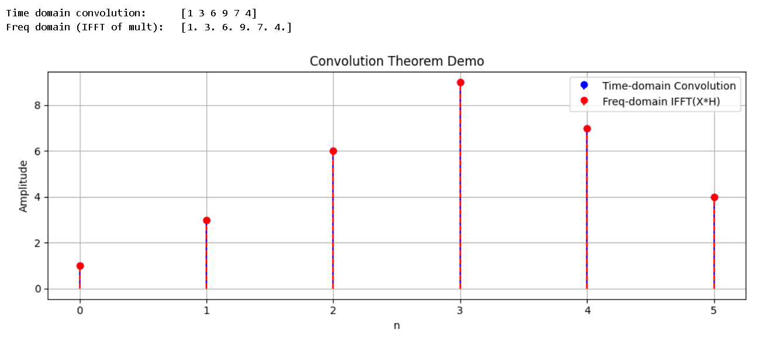Experiment 21: Low Pass Filtering of 1D Signals

#Low Pass Filtering of 1D Signals:

import numpy as np

import matplotlib.pyplot as plt

# Create a 1D signal with low + high frequency components

Fs = 1000  # Sampling frequency (Hz)

T = 1      # Duration (seconds)

t = np.linspace(0, T, Fs, endpoint=False)

f1 = 30    # Low freq

f2 = 24   # High freq

x = np.sin(2 * np.pi * f1 * t) + np.sin(2 * np.pi * f2 * t)  # Mixed signal

# Compute FFT

X = np.fft.fft(x)

freqs = np.fft.fftfreq(len(x), d=1/Fs)

# Create a low-pass filter mask

cutoff = 27  # Hz

H = np.abs(freqs) < cutoff  # Boolean mask

# Apply the low-pass filter

X_filtered = X * H

# Inverse FFT to get filtered signal

x_filtered = np.fft.ifft(X_filtered).real

# Plot original and filtered signals

plt.figure(figsize=(14, 6))

plt.subplot(4, 1, 1)

plt.plot(t, x, label='Original Signal')

plt.title("Time Domain")

plt.xlabel("Time [s]")

plt.ylabel("Amplitude")

plt.legend()

plt.grid(True)

plt.subplot(4, 1, 2)

plt.plot(freqs[:Fs//2], np.abs(X[:Fs//2]), label='Original Spectrum')

plt.title("Frequency Domain (Magnitude Spectrum)")

plt.xlabel("Frequency [Hz]")

plt.ylabel("Magnitude")

plt.legend()

plt.grid(True)

plt.subplot(4, 1, 3)

plt.plot(freqs[:Fs//2], np.abs(X_filtered[:Fs//2]), label='Filtered Spectrum', linestyle='--')

plt.title("Frequency Domain (Magnitude Spectrum)")

plt.xlabel("Frequency [Hz]")

plt.ylabel("Magnitude")

plt.legend()

plt.grid(True)

plt.subplot(4, 1, 4)

plt.plot(t, x_filtered, label='Low-pass Filtered', linestyle='--')

plt.title("Time Domain")

plt.xlabel("Time [s]")

plt.ylabel("Amplitude")

plt.legend()

plt.grid(True)

plt.tight_layout()

plt.show()

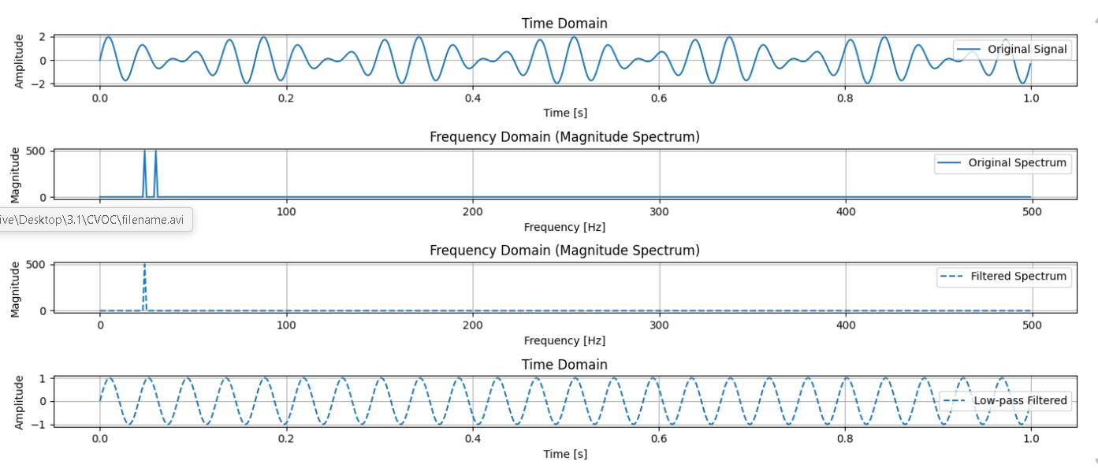

Experiment 22: Record sound in python

**pip install sounddevice soundfile**

# Record sound in pythion:

import sounddevice as sd

import soundfile as sf

duration = 5  # seconds

samplerate = 44100

print("Recording...")

audio = sd.rec(int(duration * samplerate), samplerate=samplerate, channels=1)

sd.wait()

print("Recording complete.")

sf.write('voice_recording.wav', audio, samplerate)

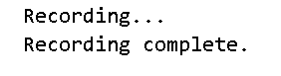

Experiment 23: Low pass and High pass filtering of real audio file

# Low pass and High pass filtering of real audio file:

import numpy as np

import soundfile as sf

import matplotlib.pyplot as plt

from scipy.fft import fft, ifft, fftfreq

# Load audio file

data, samplerate = sf.read("voice_recording.wav")  # Use your own file path

print(f"Sample rate: {samplerate}, Length: {len(data)} samples")

# Use only one channel if stereo

if len(data.shape) > 1:

    data = data[:, 0]

# Time vector

t = np.arange(len(data)) / samplerate

# FFT

N = len(data)

yf = fft(data)

xf = fftfreq(N, 1 / samplerate)

# Low-pass filter: Keep frequencies < 1000 Hz

cutoff = 9000

low_pass_mask = np.abs(xf) < cutoff

low_passed = ifft(yf * low_pass_mask)

# High-pass filter: Keep frequencies > 1000 Hz

high_pass_mask = np.abs(xf) > cutoff

high_passed = ifft(yf * high_pass_mask)

# Save filtered outputs

sf.write("low_passed.wav", np.real(low_passed), samplerate)

sf.write("high_passed.wav", np.real(high_passed), samplerate)

# Plot

plt.figure(figsize=(12, 5))

plt.subplot(1, 2, 1)

plt.plot(xf[:N//2], np.abs(yf[:N//2]))

plt.title("Original Frequency Spectrum")

plt.xlabel("Frequency (Hz)")

plt.subplot(1, 2, 2)

plt.plot(t[:1000], data[:1000])

plt.title("Time Domain Signal")

plt.tight_layout()

plt.show()

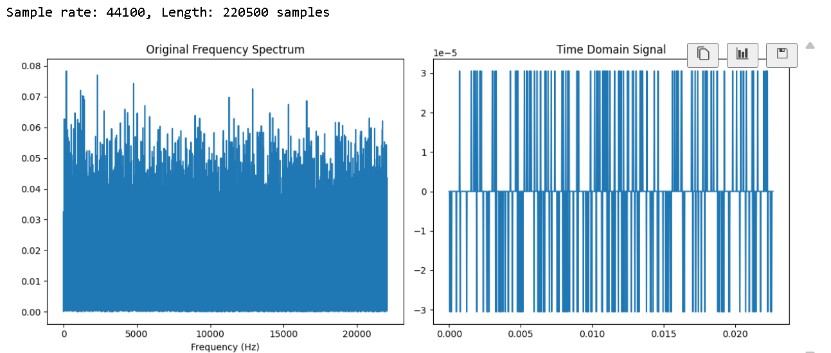

# Load audio file

data, samplerate = sf.read("gc.wav")  # Use your own file path

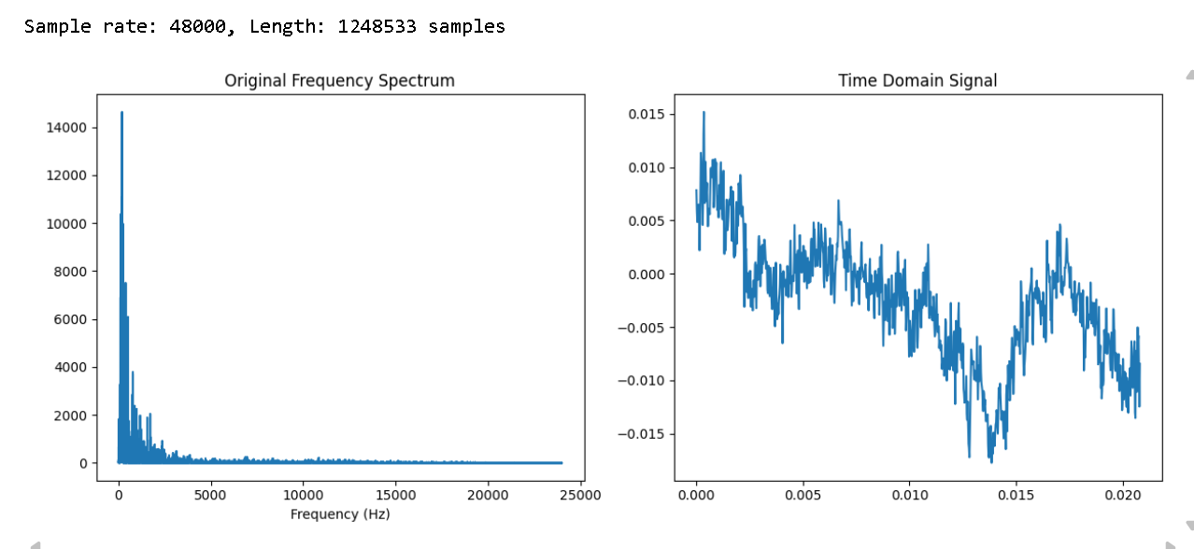

Experiment 24: Morphological Operations

# Morphological Operations:

import cv2

import numpy as np

import matplotlib.pyplot as plt

# read the image

img = cv2.imread(r"Alphabets.jpg", 0)

# binarize the image

binr = cv2.threshold(img, 0, 255, cv2.THRESH_BINARY+cv2.THRESH_OTSU)[1]

# define the kernel

kernel = np.ones((5, 5), np.uint8)

# invert the image

invert = cv2.bitwise_not(binr)

# erode the image

erosion = cv2.erode(invert, kernel,

                    iterations=2)

plt.imshow(invert, cmap='gray')

plt.show()

plt.imshow(erosion, cmap='gray')

